User Guide 8 Certifying a plan of subdivision/consolidation and issuing a Statement of Compliance
Purpose of this User Guide
The purpose of this User Guide is to assist Responsible Authorities and Applicant Contacts on how plans are certified and re-certified and the issuing of Statements of Compliance (SOC) and refusals in SPEAR.
Who should read this?
Primary audience: Responsible Authorities and Applicant Contacts
For information: Referral Authorities
Introduction
For SPEAR applications, certification is an electronic process, modelled on paper plan processes, and in accordance with the legislative requirements of the Subdivision Act 1988, and the Subdivision (Procedures) Regulations 2011. The certification decision and issuing of the SOC can only be finalised in SPEAR by a signing Responsible Authority user with a digital certificate.
8.1 How does a Responsible Authority certify a plan?
When all the referral responses to certification (Section 8) have been supplied in SPEAR by the referral authorities, the status of the application will move to ‘Certification Decision Pending’.
The Responsible Authority will then be prompted to make a certification decision.
When the Responsible Authority is satisfied that the plan is ready to be certified, they must select the mandatory action ‘Make Decision – Certif Of Subdiv’ from the Details tab.
NOTE: The consent of referral authorities’ to SOC may still be outstanding.
The Responsible Authority user will then be presented with the relevant certification options depending on the application status and whether certification and/or SOC have been achieved for the application previously.
8.2 What are the certification options in SPEAR?
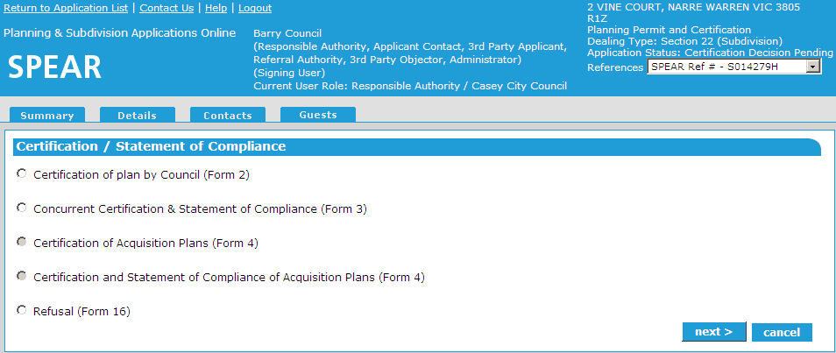
When making a certification decision in SPEAR, one of the following certification options must be selected:

Certification Options
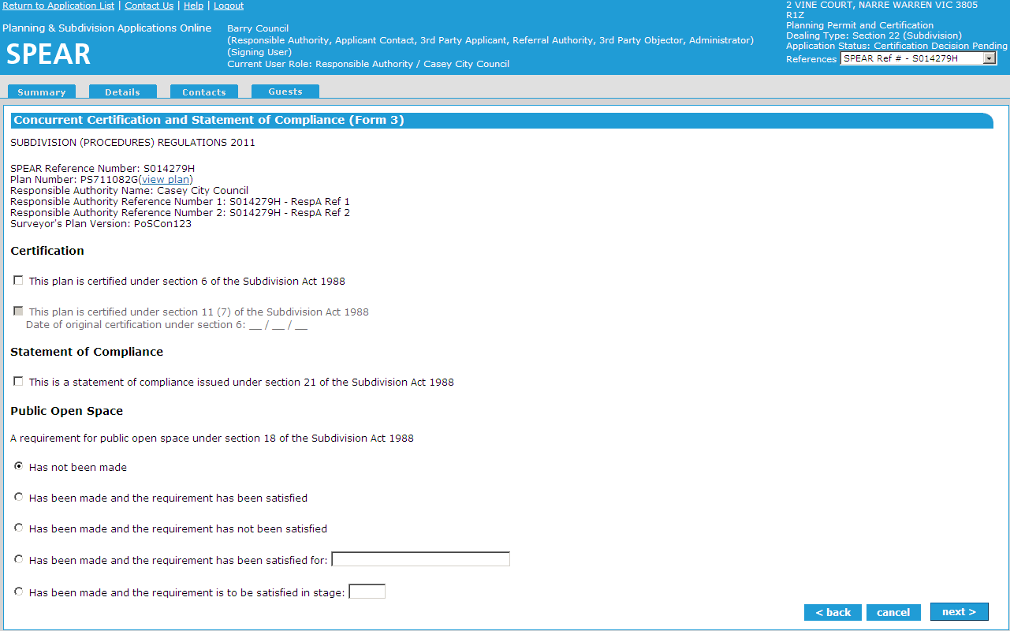
Selecting either ‘Certification (Form 2)’ or ‘Certification and SOC’ (Form 3) will take you to the Certification screen with options relevant to the form selected.

If the status of the original planning permit has been marked as ‘Lapsed’, ‘Not Required’, ‘Refused’, ‘Cancelled’, ‘Expired or ‘Withdrawn’, a red warning message will appear on the Certification screen.

If the planning permit reference number requires updating, then it can be updated or removed in this screen. When the plan is certified, the planning permit reference number is watermarked in the certification panel.

Certification & Statement of Compliance
Form 4 will only be available for applications submitted under Section 35 and Section 35(8) of the Subdivision Act (acquisition of land by an acquiring authority).
If ‘Certification (Form 2)’ has been selected the status of the application will be ‘Certification Decision’, and the Applicant Contact and referral authorities will be notified by email that a certification decision has been made.
If ‘Concurrent Certification & SOC (Form 3)’ has been selected, the status of the application will be ‘Statement of Compliance’ (SOC), and the Applicant Contact and referral authorities will be notified by email that the plan has been certified and a SOC has been issued.
To complete any of these actions, the certification decision must be authenticated using a digital certificate.
The application is locked when a plan is certified. The plan can only be amended if the Applicant Contact creates an application to amend the certified plan by submitting a Form 8 (Re-Certification) with a new version of the plan of subdivision.
The certified plan of subdivision will carry a watermark on sheet one of the plan providing details of the certification.

How does a Responsible Authority refuse certification (Form 16)?
If the ‘Refuse Certification (Form 16)’ option is selected, you will be directed to the refusal screen with options relevant to the (Form 16).

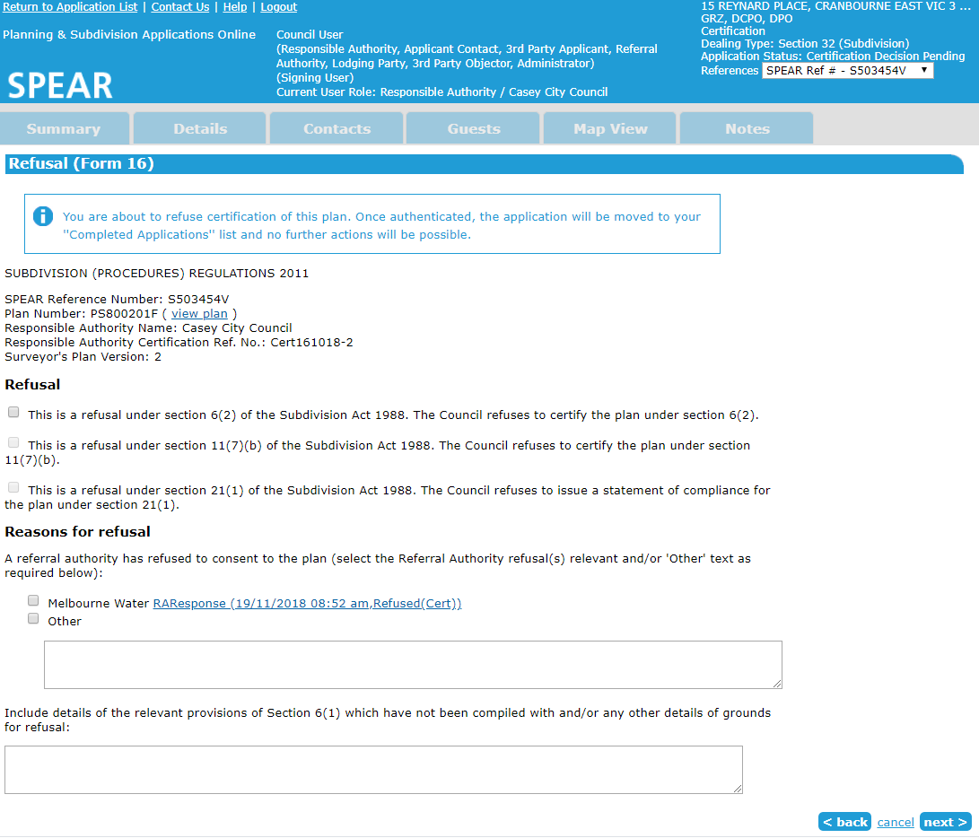

Select the section of the Subdivision Act used to refuse certification and provide the grounds for refusal.
NOTE: If one or more referral authorities have refused consent to certification, they will appear in the ‘Reasons for refusal’.
To complete this action, the refusal (Form 16) must be authenticated using a digital certificate.
8.3 How does a Responsible Authority issue a Statement of Compliance (Form 14 or Form 15)?
Once a Responsible Authority is ready to issue a SOC for a previously certified plan, they select the mandatory action to ‘Add Decision – Statement of Compliance’. The next screen will display the SOC options relevant to the plan type.
If issuing a SOC for a staged plan (Form 14) it will need to indicate the lots receiving SOC, and the lots which are not released from the original requirements.
If certification and SOC are issued separately, the certification panel will be updated with the SOC date.

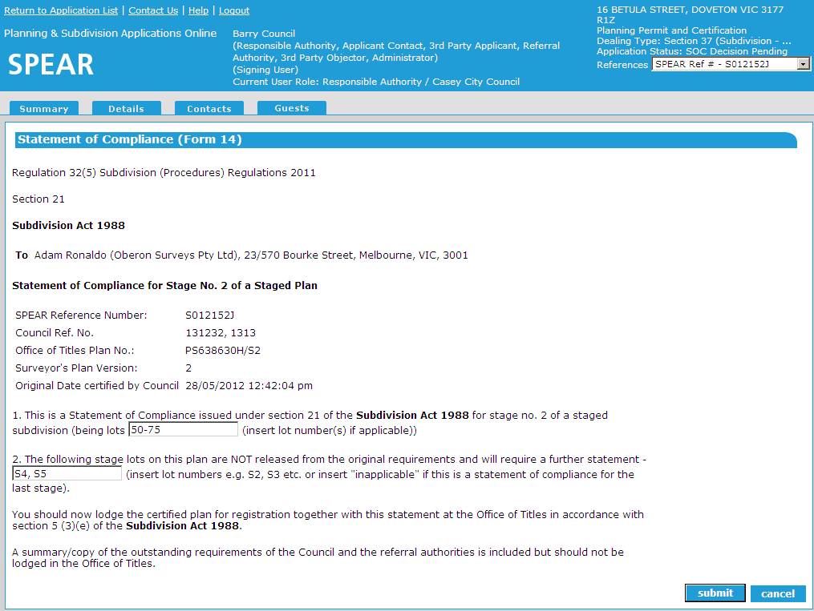
If a requirement for Public Open Space has been made but not satisfied at certification, it must be satisfied by the time SOC is issued. The Responsible Authority will have the opportunity to re-address outstanding Public Open Space requirements when SOC is issued. The certification document will be automatically updated to reflect the updated Public Open Space status.
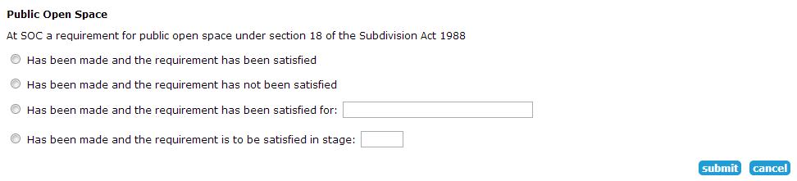

8.4 How does the Applicant Contact submit an amended plan for
re-certification?

Once the application status reaches ‘Certification Decision’ or later, the Applicant Contact must select ‘Add Application to Amend Certified Plan (Form 8)’ from the ‘Other Actions…’ drop-down list and attach a new version of the plan of subdivision. This request is received by the Responsible Authority.
After a new version of the plan is added, the Applicant Contact must complete the application to amend certified plan (Form 8) form and ‘Add Owners Consent to Amend Certified Plan’.
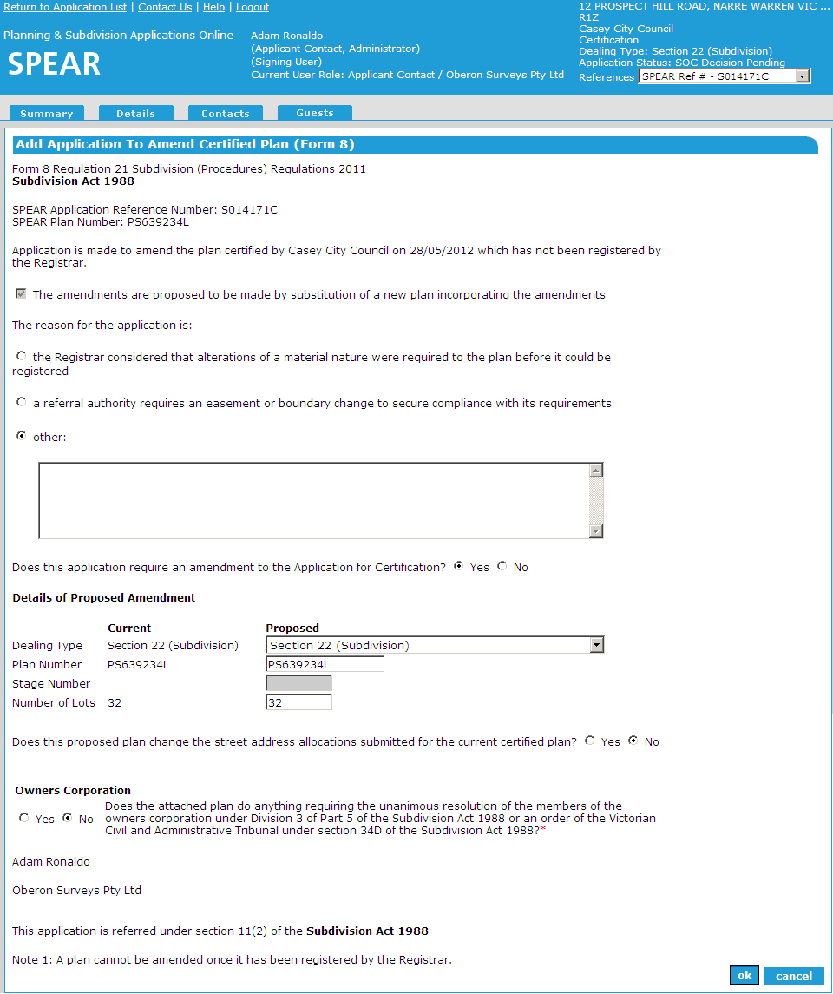

The application to amend certified plan (Form 8) must be authenticated and the plan of subdivision digitally signed by a Licensed Surveyor, before the Applicant Contact can ‘Submit Application to Amend Certified Plan (Form 8)’ to the Responsible Authority.

NOTE: The proposed plan will not replace the current version of the previously certified plan until the Responsible Authority has accepted the application for re-certification.

Application for re-certification (Form 8)
A notification will be sent to the Responsible Authority indicating a Form 8 and a ‘Proposed Plan of Subdivision for Re-Certification’ has been submitted by the Applicant Contact. SPEAR will create a mandatory action for the Responsible Authority to ‘Assess application to amend certified plan’. This will allow the Responsible Authority to assess the re-certification request.
If the application is a joint planning permit and certification application, the Responsible Authority will have the option of accepting the application and choosing whether to request that the Applicant Contact submit a revised version of the plan for endorsement. The Responsible Authority will also have the option of rejecting the application. If the application is rejected the Responsible Authority will be prompted to attach a reason prepared previously in PDF format. If the Responsible Authority accepts the changes to the application the Responsible Authority must then indicate whether the address allocations have changed since the previous certification.
8.5 How does the Applicant Contact delete/withdraw an application to amend certified plan (Form 8)?

If an application to amend a certified plan (Form 8) is no longer required before it is submitted to the Responsible Authority, it can be deleted.
Once an application to amend a certified plan (Form 8) and supporting documents have been submitted to the Responsible Authority, the Applicant Contact can withdraw the Form 8, provided the Responsible Authority has not yet accepted the Form 8 request. If withdrawn, the proposed plan of subdivision and owners consent will be removed from the application.
8.6 How does the Responsible Authority assess an application to amend a certified plan (Form 8)?

If the application is a certification-only application, the Responsible Authority will have the option of either accepting or rejecting the application.
On completion of the assessment, SPEAR will notify the Applicant Contact of the Responsible Authority's decision.
If the application is accepted by the Responsible Authority, the ‘Proposed Plan of Subdivision’ will be renamed to the ‘Plan of Subdivision’ and will become the current version. The application status will revert to ‘Certification Decision Pending’. A mandatory action for the Responsible Authority to ‘Re-check Referral Request’ and ‘Recheck’ will appear. If the Responsible Authority has indicated that the address allocations have changed then a mandatory action to ‘Modify/Confirm New Street Address Allocations’ will appear.
NOTE: Land Use Victoria may also flag the need to have a plan recertified (once the plan is lodged at Land Use Victoria). If this is the case, the applicant contact should apply for a recertified plan using the process outlined above.

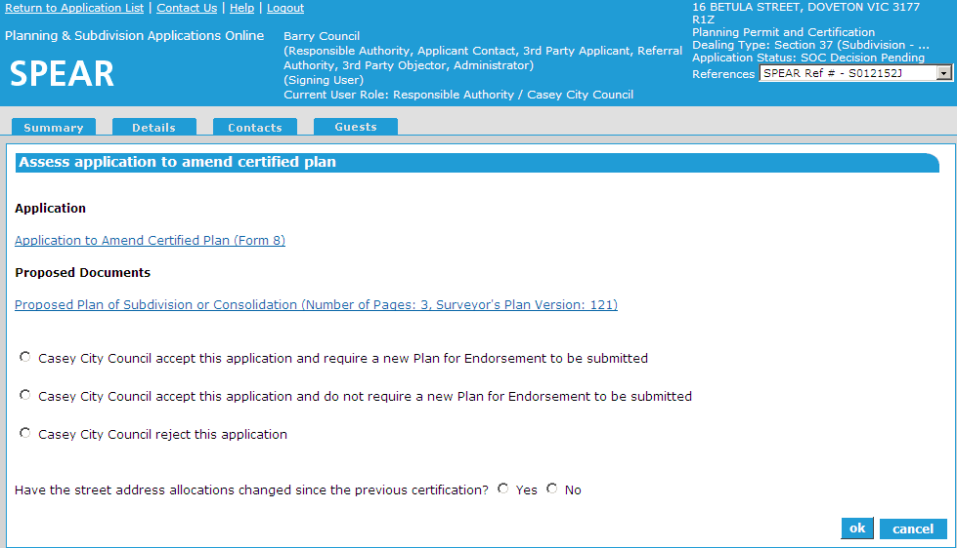

8.7 How does a Responsible Authority re-certify a plan?
The steps to complete the action for re-certification are almost the same as for the original certification, with the main difference being the forms for re-certification.
If certification/re-certification has been achieved previously the certification options available to the Responsible Authority are shown below (this may depend on the Subdivision Act plan type being dealt with):
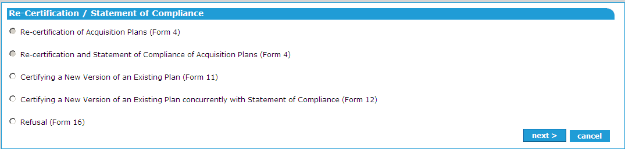

Re-Certification Options
Selecting either ‘re-certification (Form 11)’ or ‘re-certification and SOC (Form 12)’ will take you to the certification screen with options relevant to the form selected.
If ‘Refusal (Form 16)’ is selected, you will be prompted to attach a Form 16 prepared previously in PDF format.
If ‘re-certification (Form 11)’ or ‘refusal (Form 16)’ has been achieved the status of the application will become ‘Certification Decision’, and the Applicant Contact will be notified by email of the outcome.
If ‘re-certification & SOC (Form 12)’ have been achieved, the status of the application will be ‘Statement of Compliance’, and the Applicant Contact will be notified by email that the plan has been certified and a SOC has been issued.

8.8 How do I change a certification decision after it has been refused?

If a new certification decision needs to be made after the application has moved to the completed list in SPEAR, this can be achieved by restoring the application.

Select ‘Restore Refused Application’ from the ‘Other actions…’ drop-down menu.
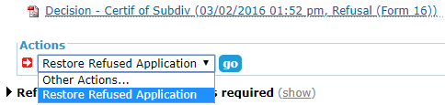

You will be prompted to provide a reason and either attach a PDF or enter a reason directly into SPEAR.

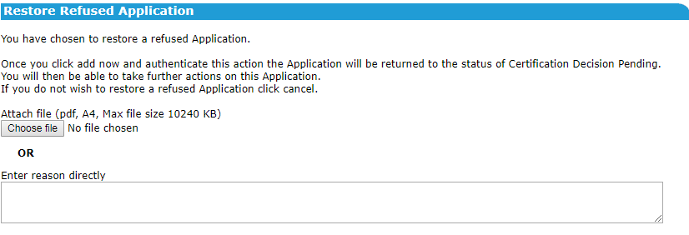

After authenticating, the application status will change to ‘Certification Decision Pending’ and all actions normally available at that status will appear.
8.9 Does SPEAR accommodate the Growth Areas Infrastructure Contribution?
The Growth Areas Infrastructure Contribution (GAIC) may be payable for subdivisions of land in growth area councils. The Responsible Authority must notify the State Revenue Office (SRO) when a Statement of Compliance (SOC) has been issued over GAIC affected land.
When SOC is issued for an Urban Growth Zone property, SPEAR will prompt the Responsible Authority to indicate whether the property may be subject to a GAIC.
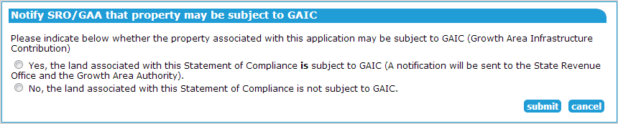

If you indicated that the property may be subject to a GAIC, SPEAR will automatically send an email notification to the State Revenue Office, together with a copy of the SOC.
If there is no zone information available in SPEAR, the notification can be sent via the optional action Notify SRO that property may be subject to GAIC.
Need more information?
Further information on this topic can be found by:
- Visiting the SPEAR website www.spear.land.vic.gov.au/SPEAR
- Contacting the SPEAR Service Desk on 9194 0612 or email spear.info@delwp.vic.gov.au

